Project Name: Live WordPress
Description: This project focuses on deploying a highly available and resilient WordPress application on an Amazon EC2 instance running Amazon Linux. The setup ensures continuous availability and automatic recovery of the WordPress environment in case of failures.

Activities:
- Create a CloudFormation stack
- Create an AMI of the WordPress instance
- Create EC2 Instance Alarm
- Configure Auto Scaling to launch a new WordPress instance
- Install And Configure WordPress instance
- Configure the new WordPress instance to shut down automatically

Create a CloudFormation stack:
Stack Name: Project-CF
- Create Amazon Linux image with
  - Image name Project-WP
  - Image: ami-052064a798f08f0d3
  - Instance: t2.micro
- Select key – “ProjectKey”. If this does not exists then create one
- Select security group – “Project-securityGroup”. If this is missing then create a new one in default VPC. Allow all inbound traffic.

Code
YAML | AWSTemplateFormatVersion: '2010-09-09'  Description: Create a t2.micro EC2 instance (Project-WP) using Amazon Linux 2 AMI with key ProjectKey and security group Project-securityGroup.  Parameters:  KeyPairName:  Type: String  Default: ProjectKey  Description: EC2 KeyPair name to use or create if missing.  DefaultVpcId:  Type: AWS::EC2::VPC::Id  Description: Select the default VPC where the instance will be created.  Resources:  # Create a key pair named ProjectKey (if it doesn’t exist)  ProjectKey:  Type: AWS::EC2::KeyPair  Properties:  KeyName: !Ref KeyPairName  KeyType: rsa  # Create a security group named Project-securityGroup in the default VPC  ProjectSecurityGroup:  Type: AWS::EC2::SecurityGroup  Properties:  GroupName: Project-securityGroup  GroupDescription: Allow all inbound traffic  VpcId: !Ref DefaultVpcId  SecurityGroupIngress:  - IpProtocol: -1  CidrIp: 0.0.0.0/0  # Create EC2 instance  EC2Instance:  Type: AWS::EC2::Instance  Properties:  InstanceType: t2.micro  ImageId: ami-052064a798f08f0d3  KeyName: !Ref KeyPairName  SecurityGroupIds:  - !Ref ProjectSecurityGroup  Tags:  - Key: Name  Value: Project-WP  Outputs:  InstanceId:  Description: Instance ID  Value: !Ref EC2Instance  PublicIP:  Description: Public IP address of EC2 instance  Value: !GetAtt EC2Instance.PublicIp  KeyPairUsed:  Description: Key pair used or created  Value: !Ref KeyPairName  SecurityGroupUsed:  Description: Security group used or created  Value: !Ref ProjectSecurityGroup

Screen shot
Clou Formation | 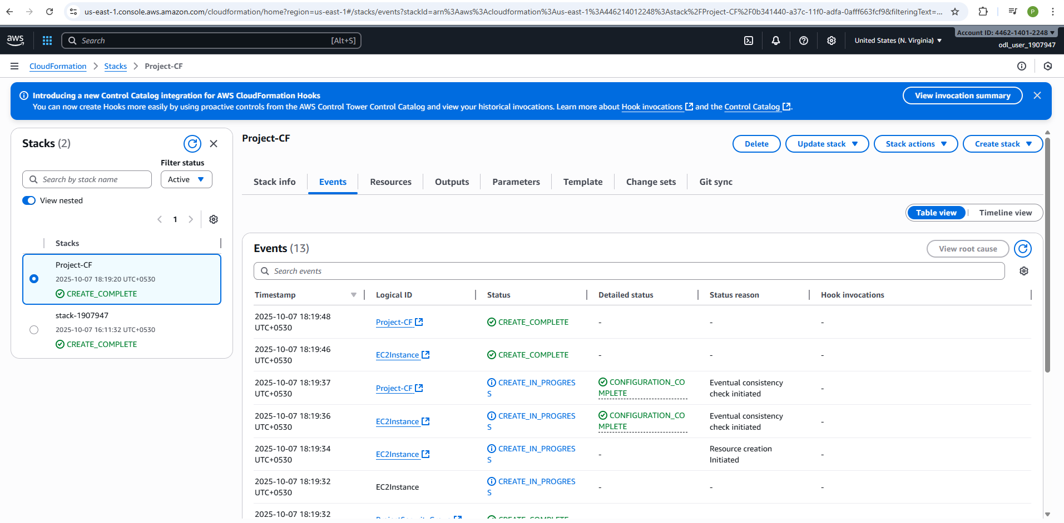
EC2 Instance | 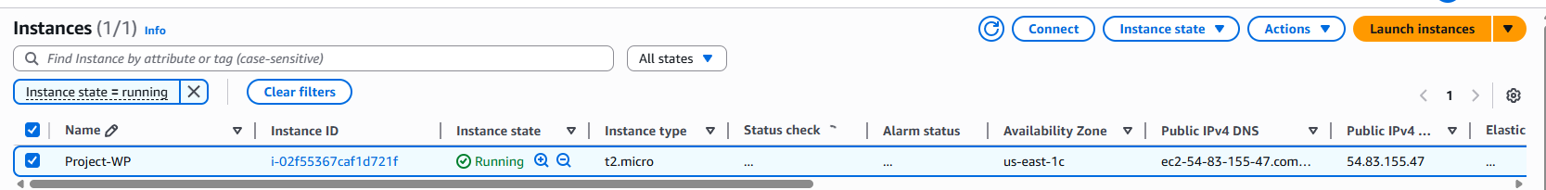
Connection | 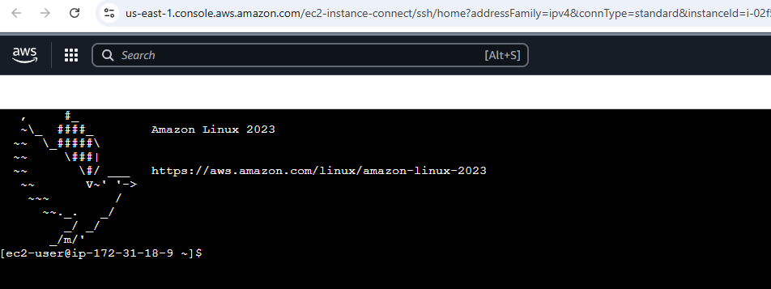

Create an AMI of the WordPress instance
Select create image

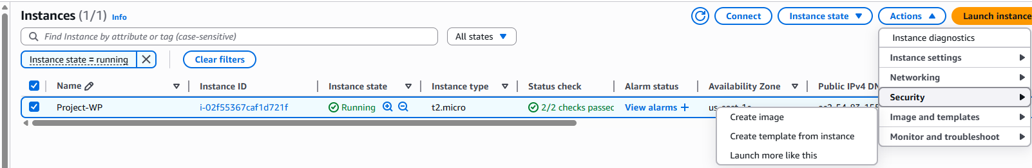
Image Name: “Project-WP-AMI”

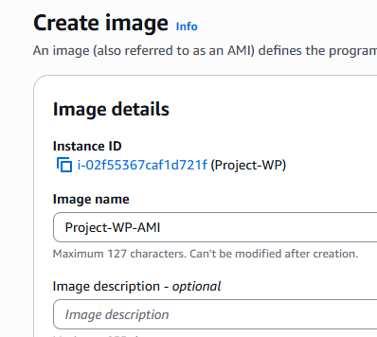
EC2 Images AMIs
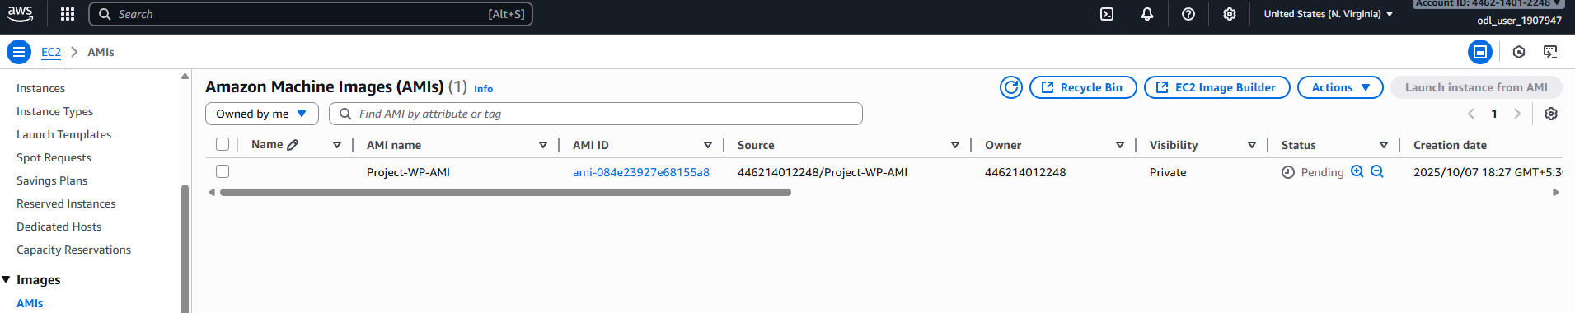

Create EC2 Alarm
Amazon SNS Topics Create Topic
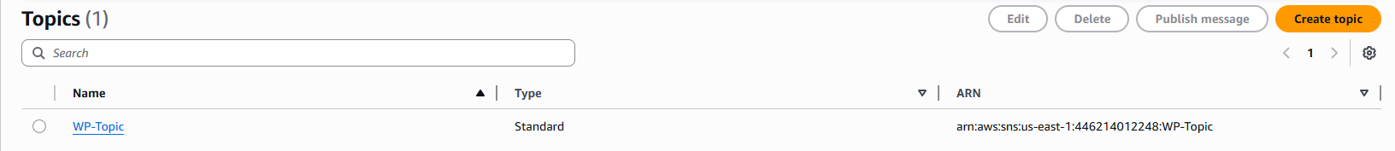

Amazon SNS Subscriptions
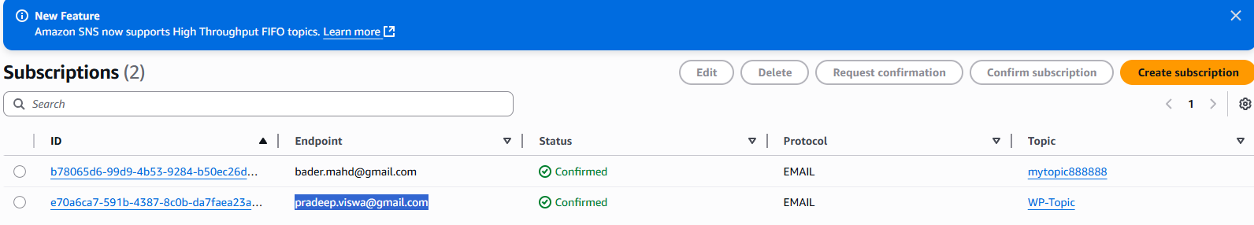
CloudWatch Alarms All Alarms Create Alarm Select Mertic EC2 Per-Instance Metrics CPU Utilization
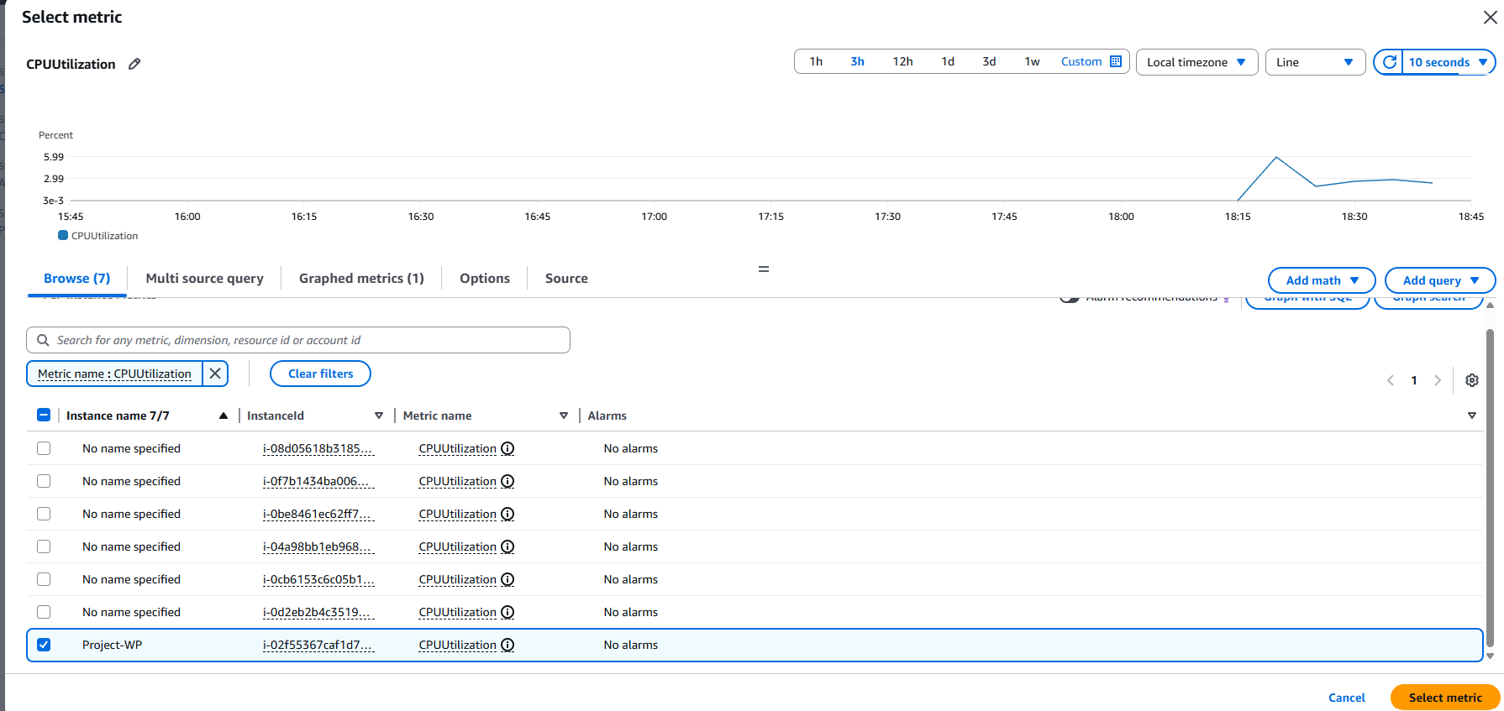

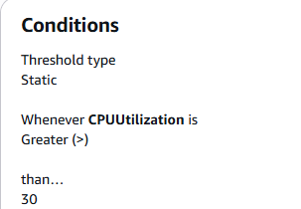
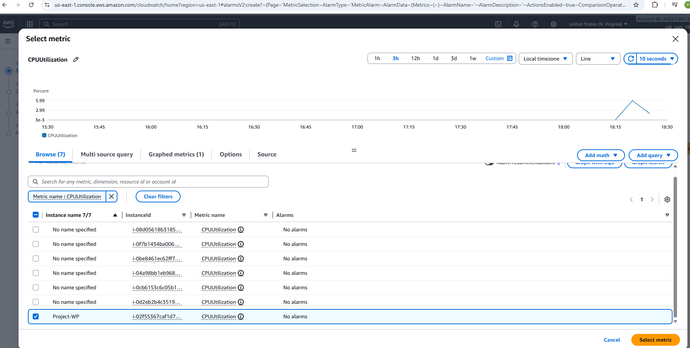
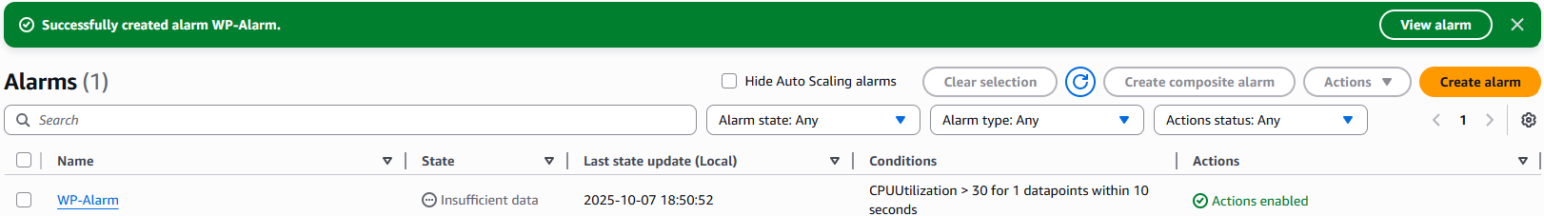

Configure Auto Scaling to launch a new WordPress instance
EC2 select Instance Actions Image and Templates – Create template from this instance

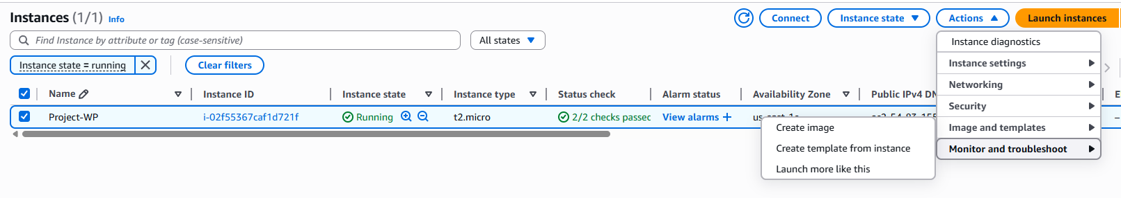

Launch Templates

EC2 Auto Scaling Auto Scaling Groups
Crate Autoscaling Group
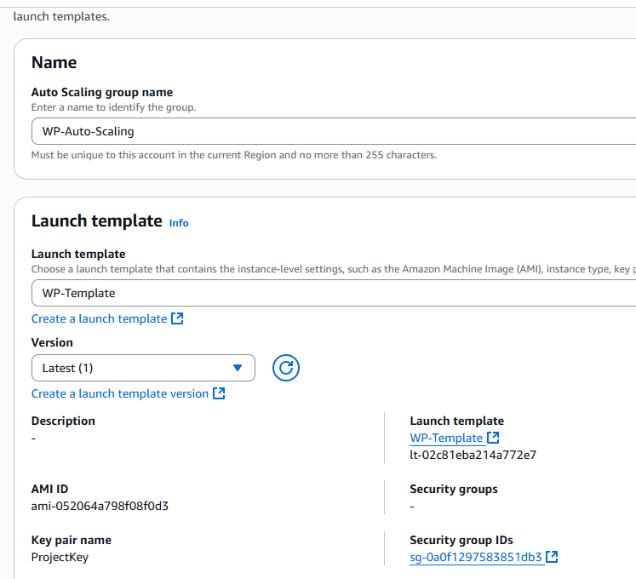

Autoscaling metrics: Desired 1, Min 1, max 5
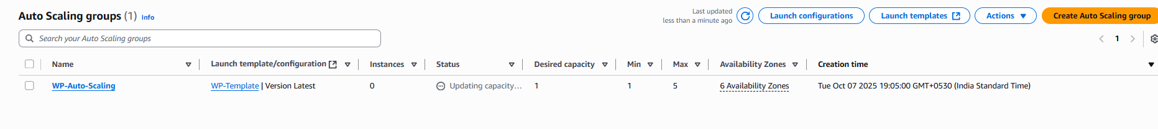

Install And Configure WordPress instance
Prerequisites  • Spring Boot  • Jenkins  • Docker  • AWS  • Git and GitHub | #update system  sudo yum update -y  # Install Apache  sudo yum install -y httpd  # Start Apache  sudo systemctl start httpd  sudo systemctl enable httpd  # Install MariaDB (MySQL compatible)  sudo dnf install -y mariadb105-server  sudo systemctl start mariadb  sudo systemctl enable mariadb  systemctl status mariadb  # Install PHP  sudo amazon-linux-extras enable php8.0  sudo yum install -y php php-mysqlnd  sudo systemctl restart httpd  # Install docker on Amazon Linux  sudo dnf update -y  sudo dnf install -y docker  sudo systemctl start docker  sudo systemctl enable docker  sudo usermod -aG docker ec2-user  docker –version  #Install Git  sudo dnf install -y git  git --version  #Installing AWS CLI v2..."  sudo curl "https://awscli.amazonaws.com/awscli-exe-linux-x86_64.zip" -o "awscliv2.zip"  sudo dnf install -y unzip  sudo unzip -q awscliv2.zip  sudo ./aws/install  aws --version  #Install Java (for Spring Boot & Jenkins)  sudo dnf install -y java-17-amazon-corretto  java -version  echo "export JAVA_HOME=/usr/lib/jvm/java-17-amazon-corretto.x86_64" >> ~/.bashrc  echo "export PATH=\$JAVA_HOME/bin:\$PATH" >> ~/.bashrc  source ~/.bashrc  #Installing SDKMAN for Spring Boot...  curl -s "https://get.sdkman.io" | bash  source "$HOME/.sdkman/bin/sdkman-init.sh"  sdk install springboot  spring --version

Secure the Database  - Set root password  - Remove anonymous users  - Disallow remote root login  - Remove test database  - Reload privileges | # Run the MySQL secure installation:  sudo mysql_secure_installation  # Log in to MySQL and create a database for WordPress:  sudo mysql -u root -p  CREATE DATABASE wordpress;  CREATE USER 'wpuser'@'localhost' IDENTIFIED BY 'wppassword';  GRANT ALL PRIVILEGES ON wordpress.* TO 'wpuser'@'localhost';  FLUSH PRIVILEGES;  EXIT;
Install WordPress | # Download and extract WordPress:  cd /tmp  curl -O https://wordpress.org/latest.tar.gz  tar -xzf latest.tar.gz  sudo cp -r wordpress/* /var/www/html/  # Set permissions:  sudo chown -R apache:apache /var/www/html/  sudo chmod -R 755 /var/www/html/  # Configure WordPress:  cd /var/www/html  sudo cp wp-config-sample.php wp-config.php  sudo nano wp-config.php  # Update database settings:  define('DB_NAME', 'wordpress');  define('DB_USER', 'wpuser');  define('DB_PASSWORD', 'wppassword');  define('DB_HOST', 'localhost');  # Restart Apache:  sudo systemctl restart httpd

Configure the new WordPress instance to shut down automatically
Access WordPress in Browser | # Get EC2 Public IP from the AWS console.  1.Get your EC2 Public IP from the AWS console.  2.Open a browser and visit:  http://<Public-IP>  3.Complete the WordPress installation wizard:  - Site Title  - Admin Username & Password  - Email
EC2 Instance | 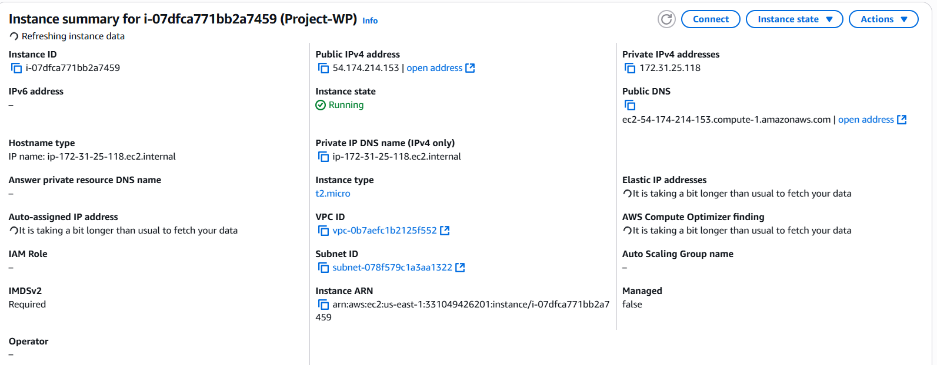
http://54.174.214.153/wp-admin/install.php | 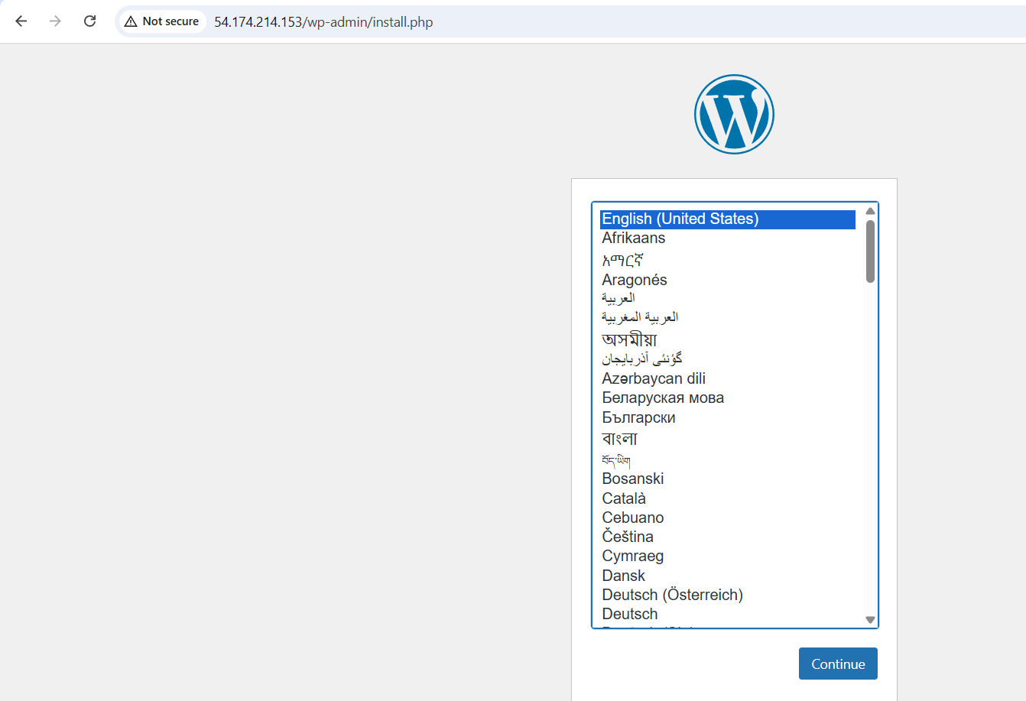
Configure  Fill detail and click on Install WordPress button | 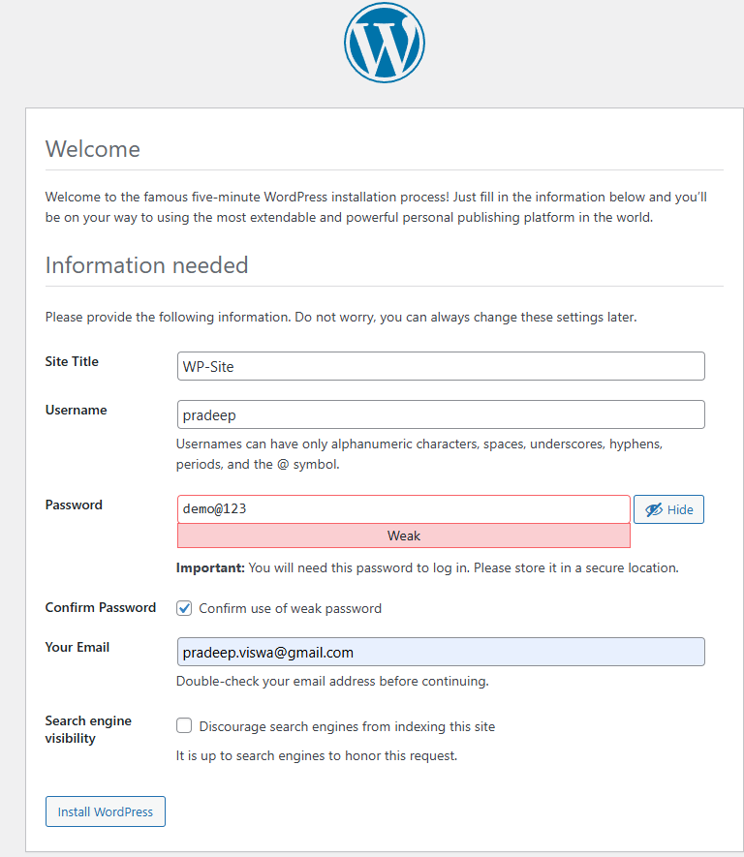 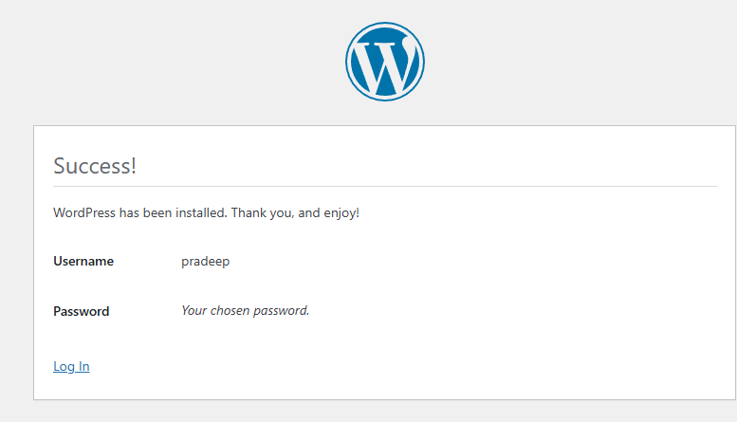
Login  http://54.174.214.153/wp-login.php | 